**Voice controlled Light system.**

Sravanthi kapu

skapu001@odu.edu

01055650

**Abstract:** This paper explains the voice controlled light system. Mostly Home Automation Systems is used to make a luxury and sophisticated home automation platforms. It makes it easy for the elderly and the disabled to control appliances in Home. The aim of the idea Controlling light system with voice recognition is to provide those with special needs with a system that can respond to voice commands and control the on/off status of electrical devices, such as lamps, fans, television etc, in the home .The system should be reasonably cheap, easy to configure, and easy to run. Here we can also control our lights with a SMS; also lights can be On/Off by sensing the light intensity in room. There is a control on the users who can access the system in the home, so the users should be aware of the password in order to control the light system, which also covers security.

**Literature review on related work:**

There have been many commercial and research projects on smart homes and voice recognition systems. The system integrated platform for home security, monitoring and automation (SMA) from Control is a 7-inch touch screen that can wirelessly be connected to security alarms and other home appliances. The home automation through this system requires holding and interacting with a large panel which constraints the physical movements of the user. Another popular commercially available system for home automation is from Home Automated Living (HAL).HAL software taps the power of an existing PC to control the home. It provides speech command interface. A big advantage of this system is it can send commands all over the house using the existing highway of electrical wires inside the home’s walls. No new wires means HAL is easy and inexpensive to install. However, most of these products sold in the market are heavily priced and often require significant home make over.

There are many voice recognition systems, which involve Arduino and many voice recognition techniques. Here we are using the 1sheeld which have all the sensors in it which can access when connected to our mobile through I shield app.

**Hardware used:**

1. Arduino UNO R3
2. 1Sheeld
3. 1Sheeld app
4. Jumper wires
5. LED’S
6. Resistors
7. Push button
8. Bread board

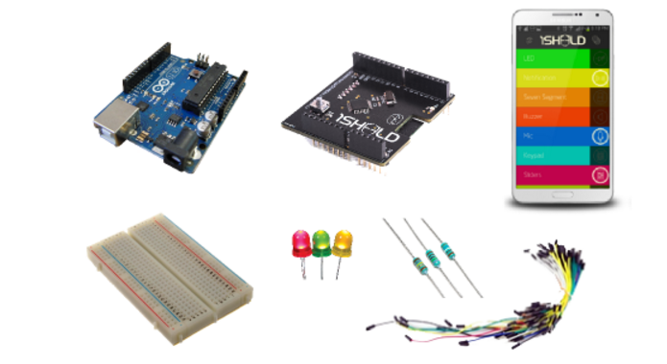

**Arduino:**

Arduino/Genuino Uno is a microcontroller board based on the ATmega328P ([datasheet](http://www.atmel.com/Images/doc8161.pdf)). It has 14 digital input/output pins (of which 6 can be used as PWM outputs), 6 analog inputs, a 16 MHz quartz crystal, a USB connection, a power jack, an ICSP header and a reset button. It contains everything needed to support the microcontroller; simply connect it to a computer with a USB cable or power it with a AC-to-DC adapter or battery to get started. "Uno" means one in Italian and was chosen to mark the release of Arduino Software (IDE) 1.0. The Uno board and version 1.0 of Arduino Software (IDE) were the reference versions of Arduino, now evolved to newer releases. [7]

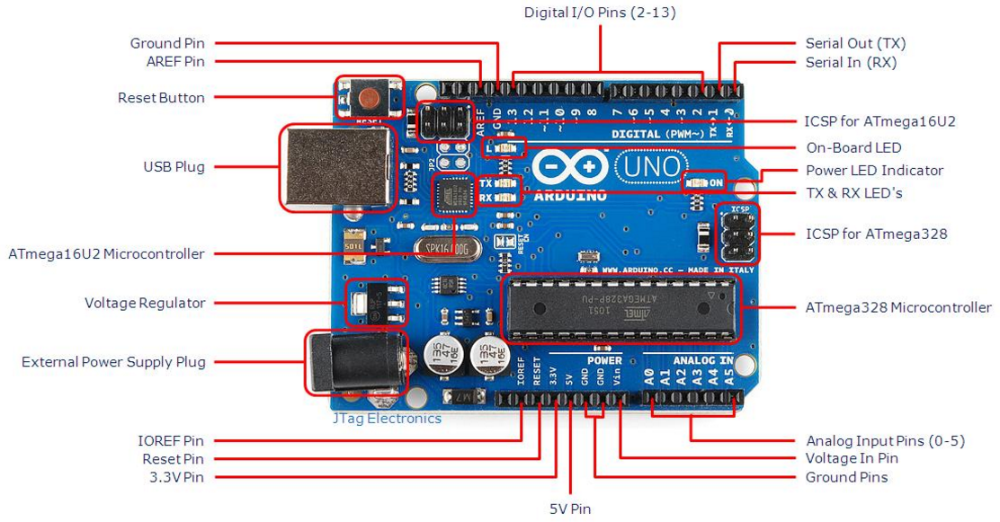

Fig: Ardiuno UNO R3

**1Shield:**

1Sheeld is a new easily configured shield for Arduino. It is connected to a mobile app that allow the usage of all of Android smartphones' capabilities such as LCD Screen, Gyroscope, Switches, LEDs, Accelerometer, Magnetometer, GSM, Wi-Fi, GPS &hellip ; etc. into your Arduino sketch.

1sheeld consists of two parts. The first part is a shield that is physically connected to your Arduino board and acts as a wireless middle-man, piping data between Arduino and any Android smartphone via Bluetooth. The second part is a software platform and app on Android smartphones that manages the communication between our shield and your smartphone and let your choose between different available shields.

variety of shields are developed for 1Sheeld like LED, Toggle Button, Buzzer, Slider, LCD, 7-Segment, Keypad, Music Player, Game Pad, Notifications, Twitter, Facebook, Foursquare, Gyroscope, SMS, Flashlight and Mic which uses the sensor in the mobile.

Technical Specifications [1]:

* Uses a standard HC-06 Bluetooth adapter (Bluetooth 2.1)
* Range up to 30 feet
* Running on an Atmel ATMega162
* 16 MHz operating frequency
* Communicate with Arduino using UART

1Sheeld works on Arduino (Uno/MegaADK/Mega2560/Leonardo/Due). [2]

Circuit:

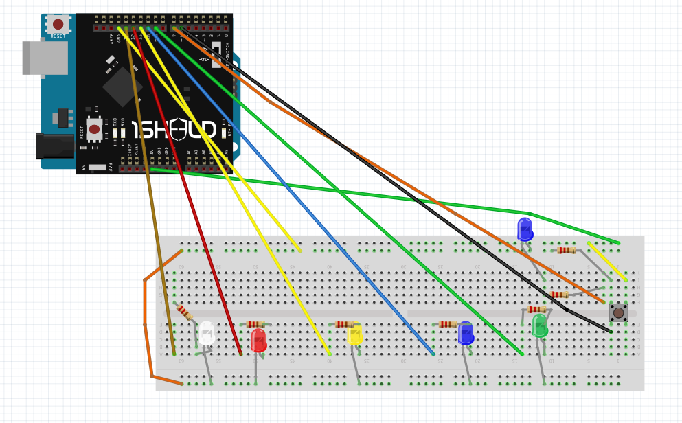

**Implementation:**

**Steps to connect 1sheeld:**

Place your 1Sheeld on your Arduino board then plug the Arduino to your laptop or PC.

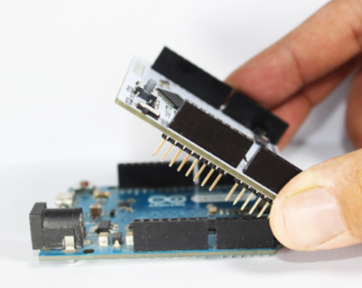

Download 1Sheeld Application onto your smart phone. The app is available on [Apple play store](https://itunes.apple.com/gm/app/1sheeld-ultimate-arduino-shield/id1082636798?mt=8) and [Google play store](https://play.google.com/store/apps/details?id=com.integreight.onesheeld&hl=en_GB)

### Download 1Sheeld library. Then, after you successfully downloaded the library, extract the files in Arudino’s library directory “Path\UserName\Documents\Arduino\libraries”.

### Now to simulate our code, we need to switch 1sheeld to upload mode and then upload the code. Upload mode is turned on when the UART switch is pushed away from the 1Sheeld logo. Or if you have 1Sheeld+ switch it to the SWS “Software serial” sign that appears on the board.

### 

### Once we have completed uploading our code, we need to switch 1Sheeld back to the operating mode

If we don’t switch the UART Switch back to the operating mode our project will not work properly as there will be no communication between 1Sheeld and the Arduino board.

Operating mode is turned on when the UART switch is pushed closest to the 1Sheeld logo. Or if you have 1Sheeld+ switch it to the HWS “Hardware Serial” sign that appears on the board.

### To connect 1sheeld to the mobile, we need to turn on the Bluetooth and then open the 1sheeld application in mobile and scan. It detects the 1sheeld and once we click on the device name, it gets paired. Now all the sensors in the mobile can be used by 1sheeld and Arduino. UART switch should be on the operating mode.

### 

### Once connected, connect the below sensors / shields: SMS, text to speech , voice recognition , light.

### SMS Shield - Allows you to send an SMS to a phone number when a certain trigger is on.

### Voice Recognition Shield- Control your Arduino with voice commands with 1 line of code, you can trigger it to control a robot or talk to your home appliances!

### Light sensor shield - This shield is one of the sensor shields. Sensor shields allows you to tap into your smartphone’s sensors and use in prototyping with Arduino, you can get information from the surrounding environment and use it to trigger a certain action.

### Text to speech shield -Let your Arduino board talk to you, get text from Arduino and convert into speech to hear through the smart phone’s speaker. This shield is one of the special shields, it allows Arduino board to use some capabilities your smartphone can do, like playing music, taking a picture, getting notifications, accessing the clock data and using the touch screen for various functions.

### Controlling lights with voice recognition:

In order to control the lights by our voice, we first need to enable the voice recognition sensor in 1shield Application in our mobile. Then tap on the speaker and by speaking which ever colour light we want or its specific name then that particular light gets on. In this project, there are 5 lights: red, blue, green, yellow and cream. There is also one more option “dance” so when this command is used, the light on and off in specific time interval until next command is given.

The list of commands and their operations:

|  |  |
| --- | --- |
| **Voice commands** | **Operation** |
| red | turns on red light |
| blue | turns on blue light |
| green | turns on green light |
| cream | turns on cream light |
| yellow | turns on yellow light |
| dance | Turns on all lights and turns off all lights one after the other till a new command is received. |
| play | turns on all lights |
| stop | turns off all lights |

Code snippet:

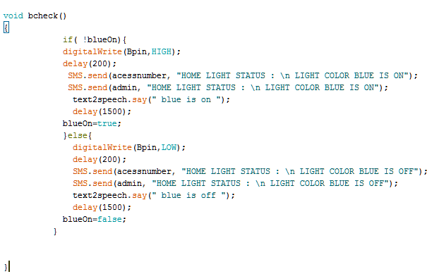

Function to check and ON blue light when a command is sent. Similar functions are used for other coloured lights.

**Controlling Lights depending on the Light intensity in the room:**

The light sensor in the 1shield app should be on. Then the sensor detects the light intensity and depending on it if the room is dark, the lights get on automatically and when it’s bright then the lights turn off automatically.

Code snippet:

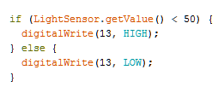

Based on the light intensity measured by sensor, if it is below 50 , the cream light turns On.

**Controlling lights with SMS and getting notifications:**

We can also control the lights by sending the SMS to the mobile which is connected to the 1shield.

Whenever the status of the lights are changed we get an SMS notification to the mobile through the lights are controlled.

**USER ACCESS:**

By sending the password as message to the sensor, the user can get access to the system to control the lights.

If the user doesn’t want access, just by sending another password, he can get out of the users list. So he can’t access the light system anymore.

**ADMIN:**

Whoever the user is, there will be one admin. We can change the admin but can never remove the admin. So in order for a client to become admin, he first needs to send a password. Then within 10 sec he needs to press the switch in the connection to get access. This system is implemented to make sure the person is having access to the home and not just a stranger gets access just by sending the password.

List of Commands that can be sent by SMS and their operations:

|  |  |
| --- | --- |
| **sms commands** | **Operation** |
| red | turns on red light |
| blue | turns on blue light |
| green | turns on green light |
| cream | turns on cream light |
| yellow | turns on yellow light |
| dance | Turns on all lights and turns off all lights one after the other till a new command is received. |
| play | turns on all lights |
| stop | turns off all lights |
| GetMeAccess007 | the person who sent the sms gets access to control light system |
| removeme | the user will lose the access to control lights |
| changeadmin | To get the admin access, need to send this command / password and then need to press the push button in specific time. |

**Ideas to implement for security:**

How can you protect this light from being accessed or controlled by non- authorized users?

We will set the authorized users list (for example the family members in the house). When a user sends password to get access, the algorithm first checks if the user is one of the authorized user or not. If he is a member of the list, just by sending password he gets the access. If he is not the one in the list, admin receives a message with the details of user who sent the password, if the admin replies OK, the user gets access. If the admin doesn’t reply the access for the unauthorized user is denied.

**CONCLUSION:**

Developed a system in which the below implementations are done:

1. Connected Ardiuno and1sheeld and able to use the sensors in1sheeld app.

2. Able to control lights using voice recognition.

3. Implemented the delivery of Message to mobile whenever the lights are accessed.

4. Implemented the voice notification through the 1sheeld app whenever the lights are accessed.

5. Can access the lights through a message.

6. Using the light sensor through the 1sheeld app and to make sure lights turn on automatically if the light intensity in the room is below a specific level.

7. To get access to another mobile number by sending the password, so if our mobile is switched off, still we can control the lights through another mobile.

8. Keeping an admin who has control to the system always, whereas another user can get the access by sending the password.

**References:**

[1] <https://www.seeedstudio.com/1Sheeld-Replace-your-Arduino-shields-with-smartphone-p-1870.html>

[2] <https://1sheeld.com/tutorials/getting-started/>

[3] <https://www.slideshare.net/AbhishekNeb/thesis-voice-control-home-automation>

[4] [https://www.hackster.io/maharaafat93/control-your-light-system-by-your-voice-bbabff?ref=channel&ref_id=424_trending___&offset=140](%20https://www.hackster.io/maharaafat93/control-your-light-system-by-your-voice-bbabff?ref=channel&ref_id=424_trending___&offset=140)

[5] <file:///C:/Users/anand/Downloads/Humaid-ICOM-2011.pdf>

[6]<https://www.hackster.io/ahmedyassin/control-your-light-system-using-smart-phone-3463b9>

[7] <https://www.arduino.cc/en/main/arduinoBoardUno>